DATA STRUCTURES AND ALGORITHMS
TASK 7.1P
AVL TREES
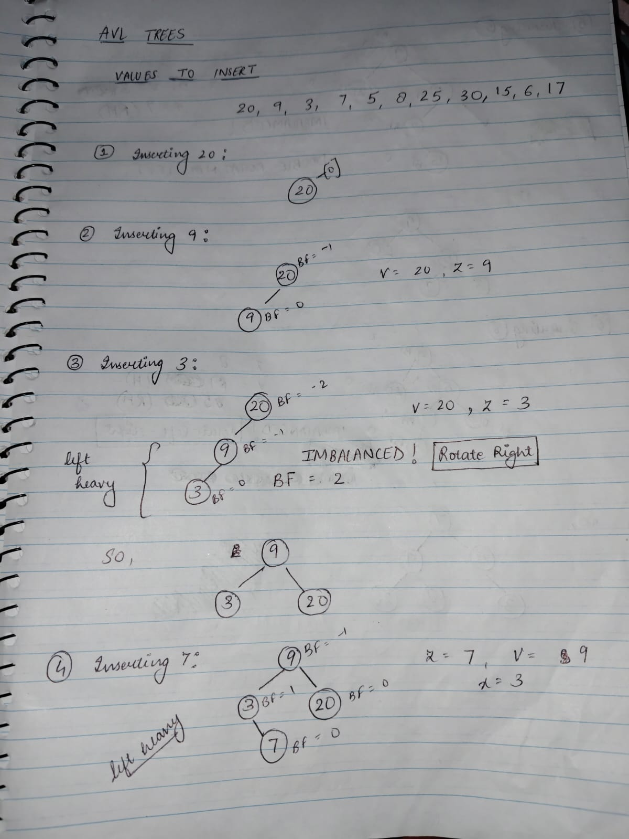

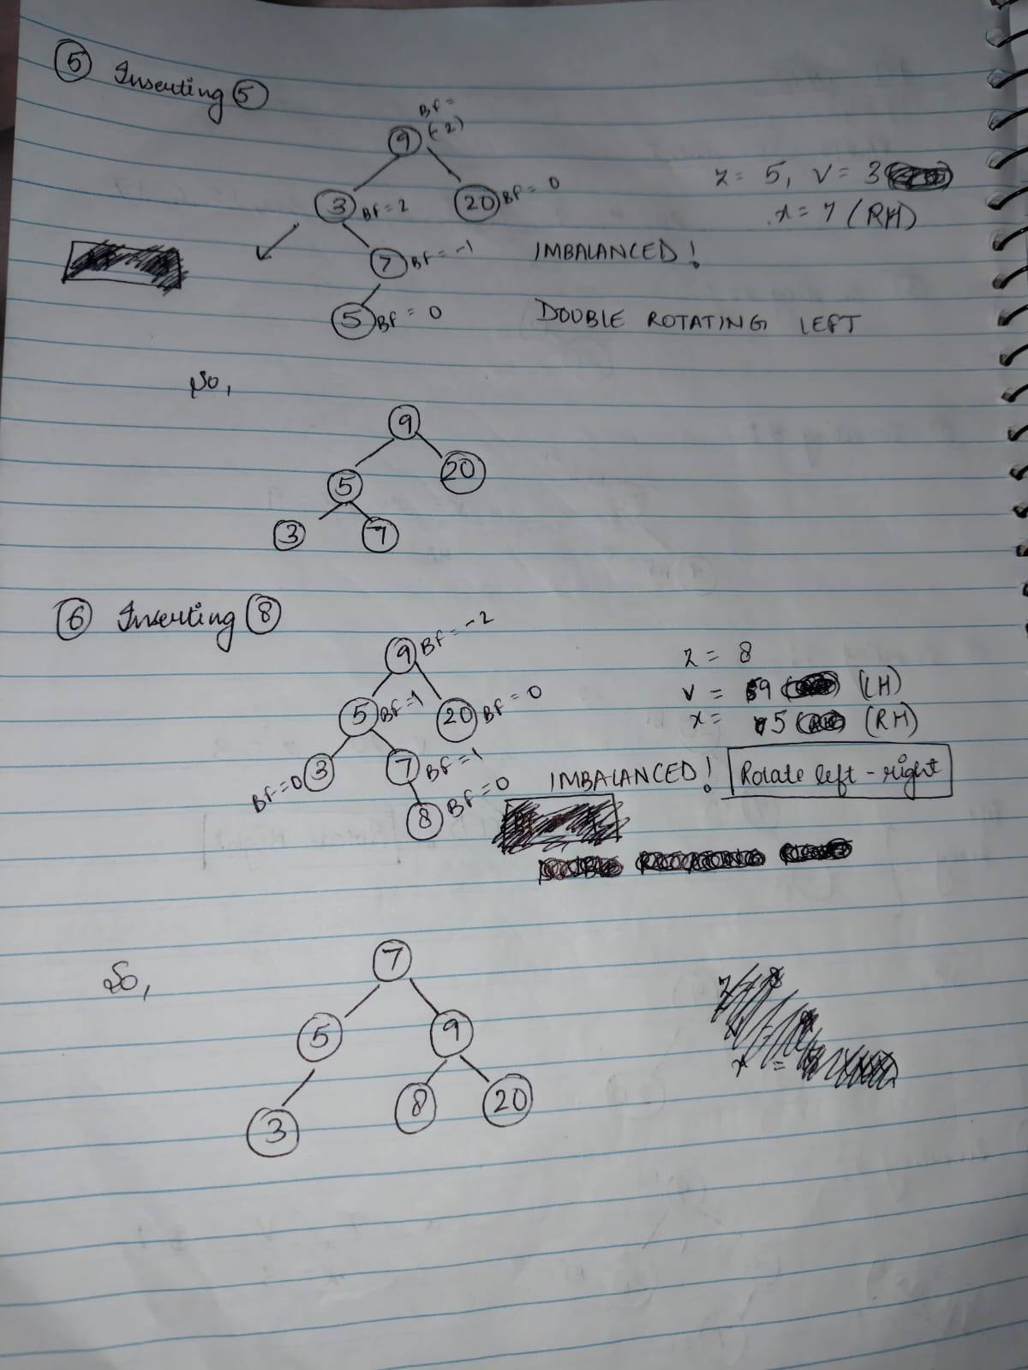
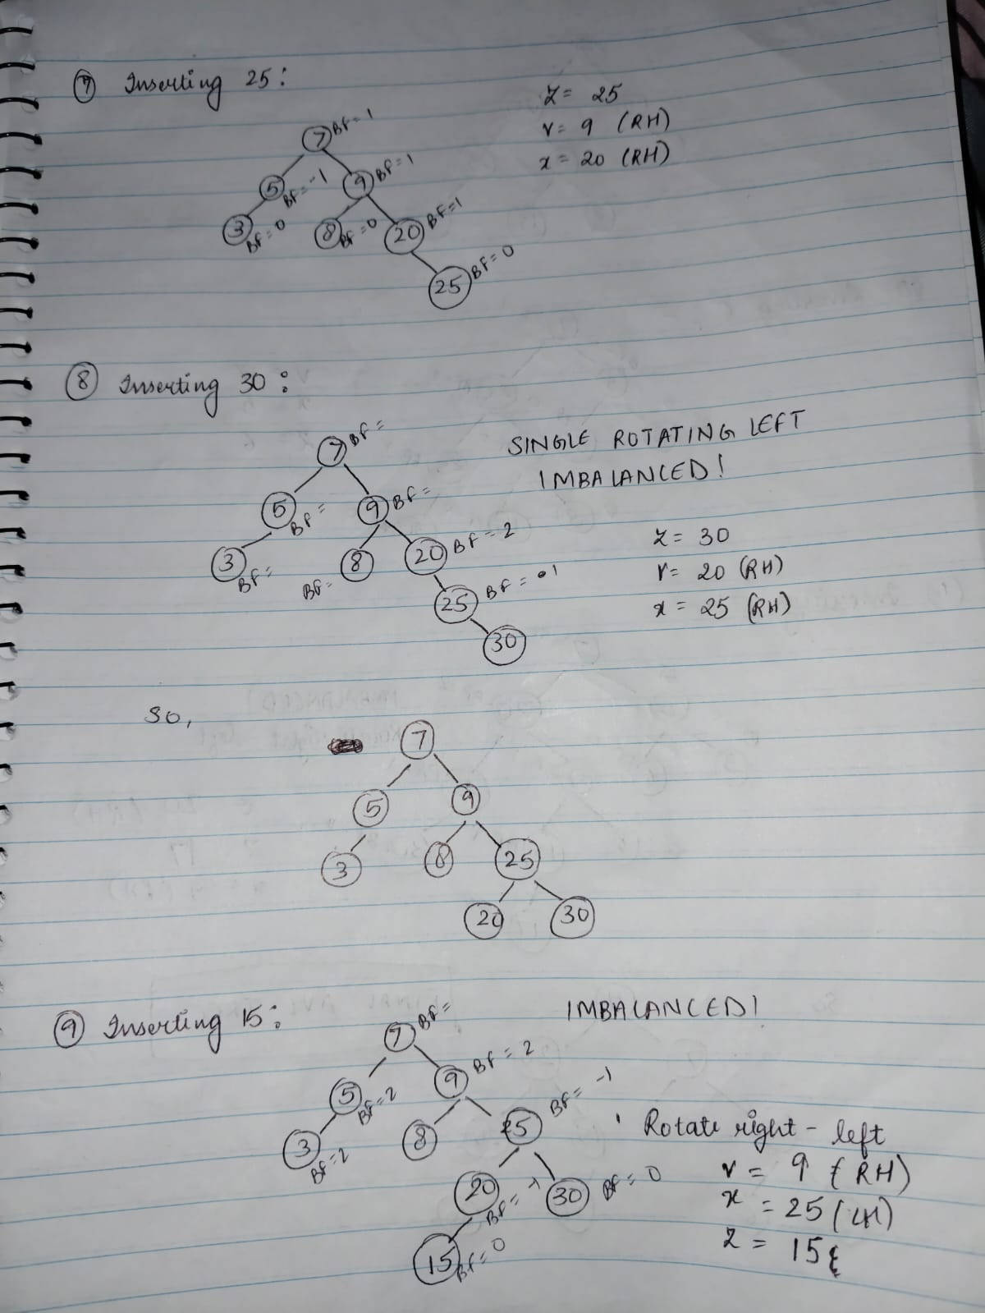
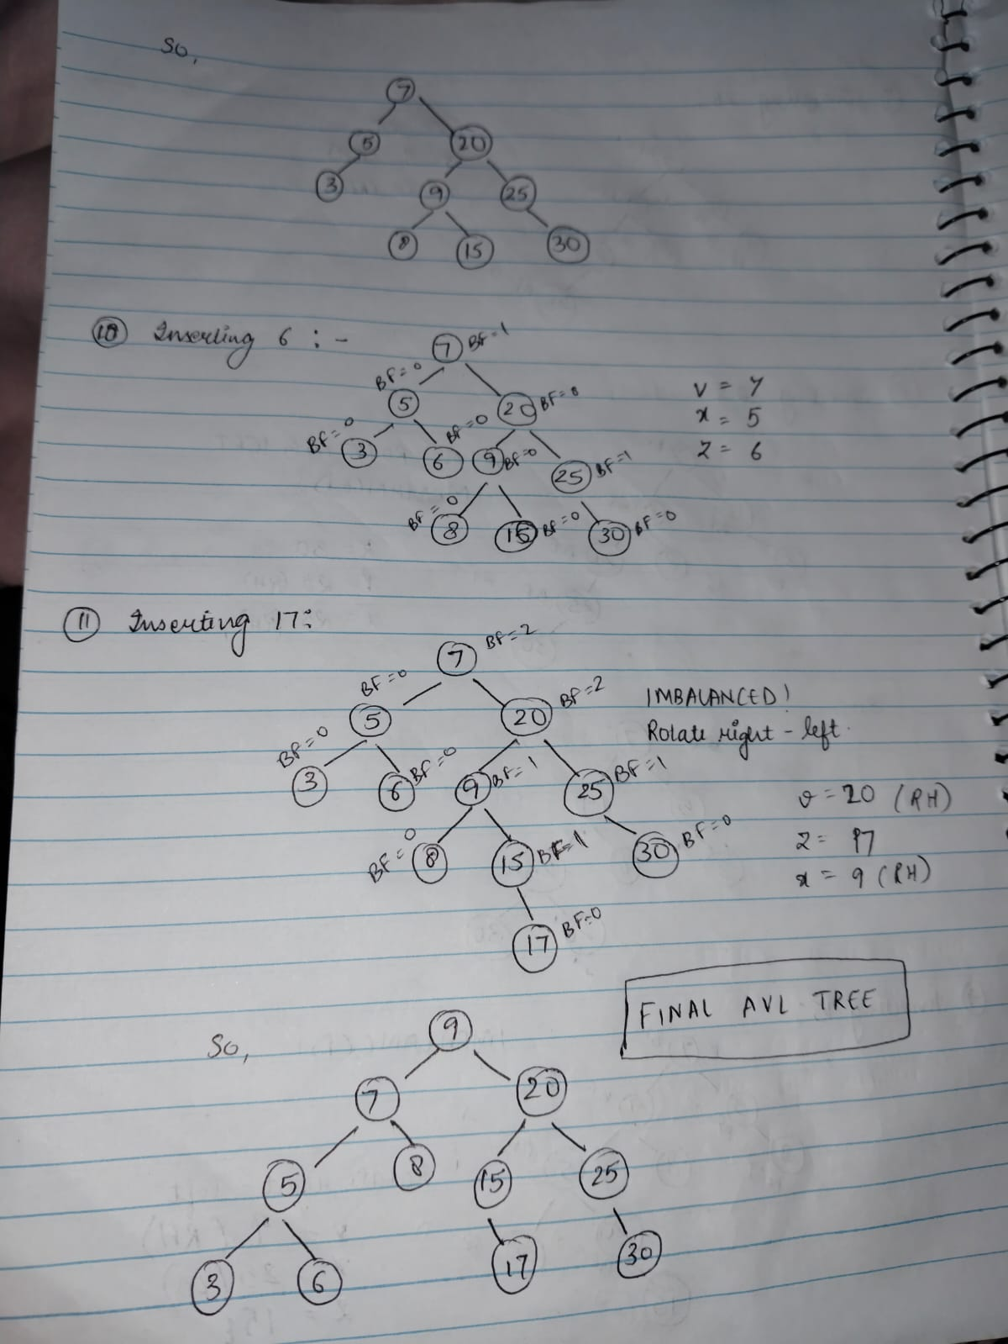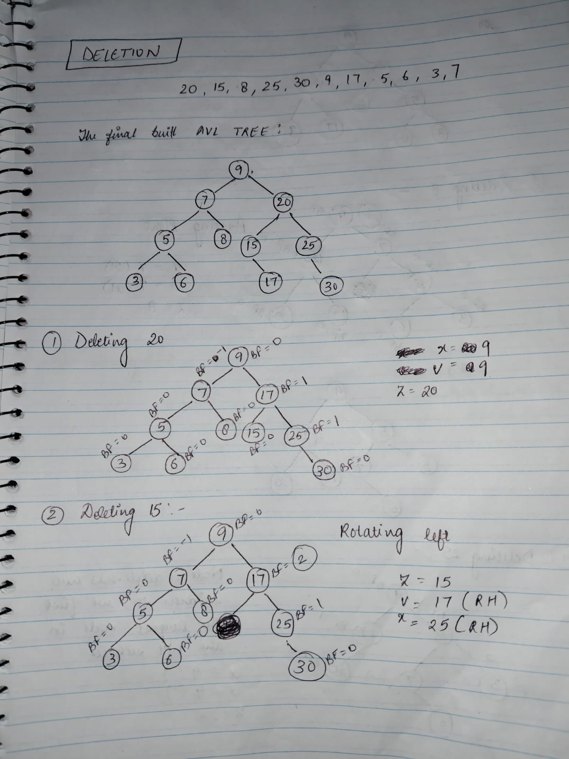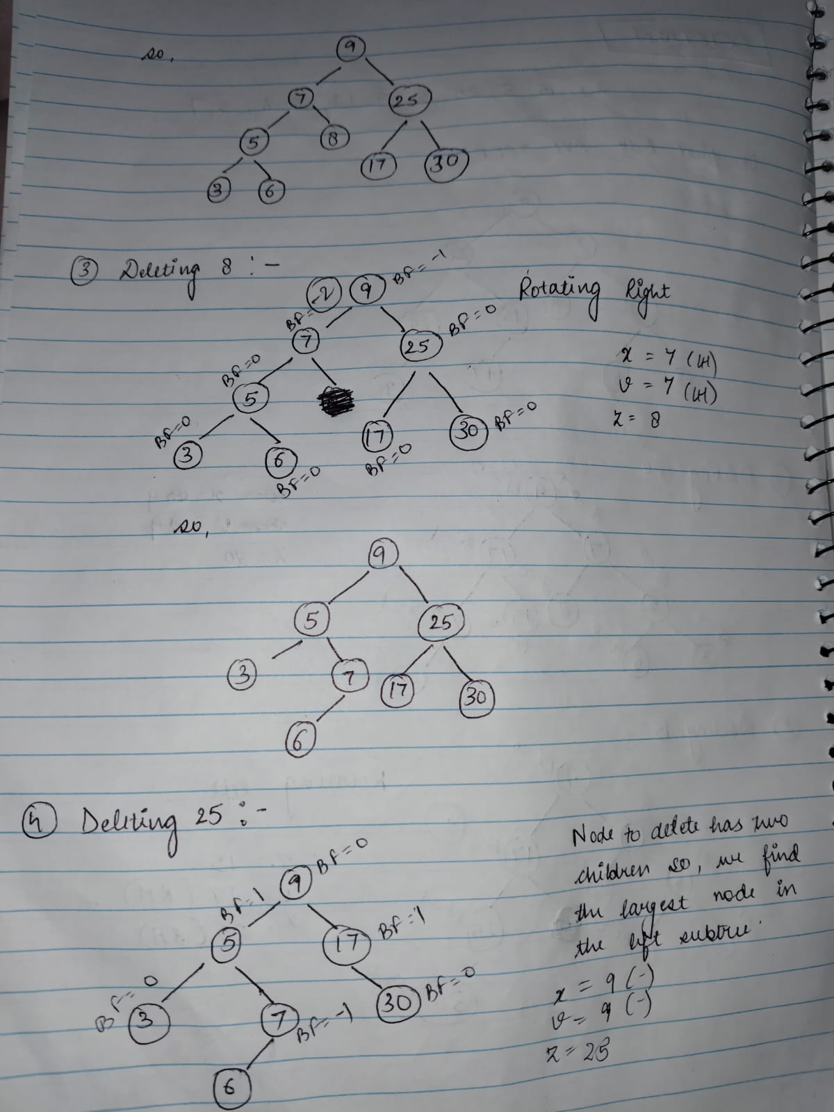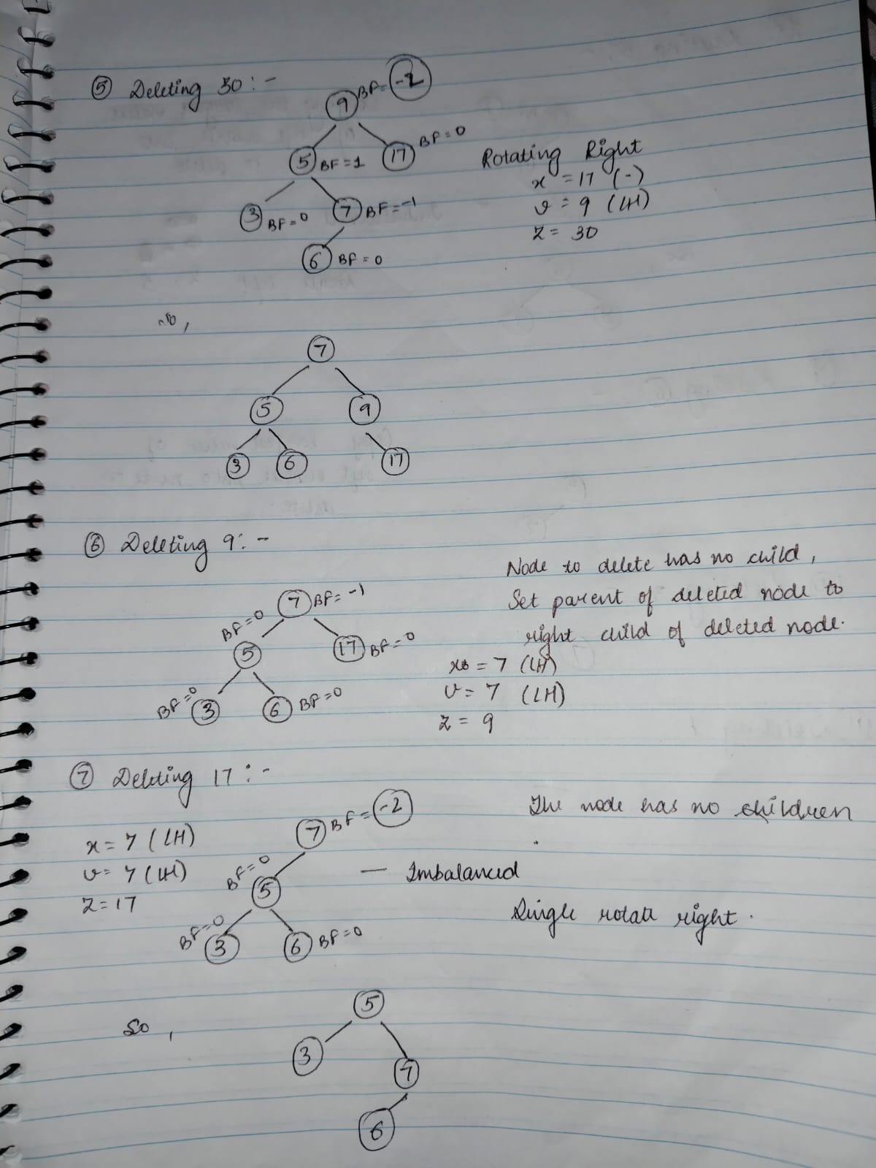
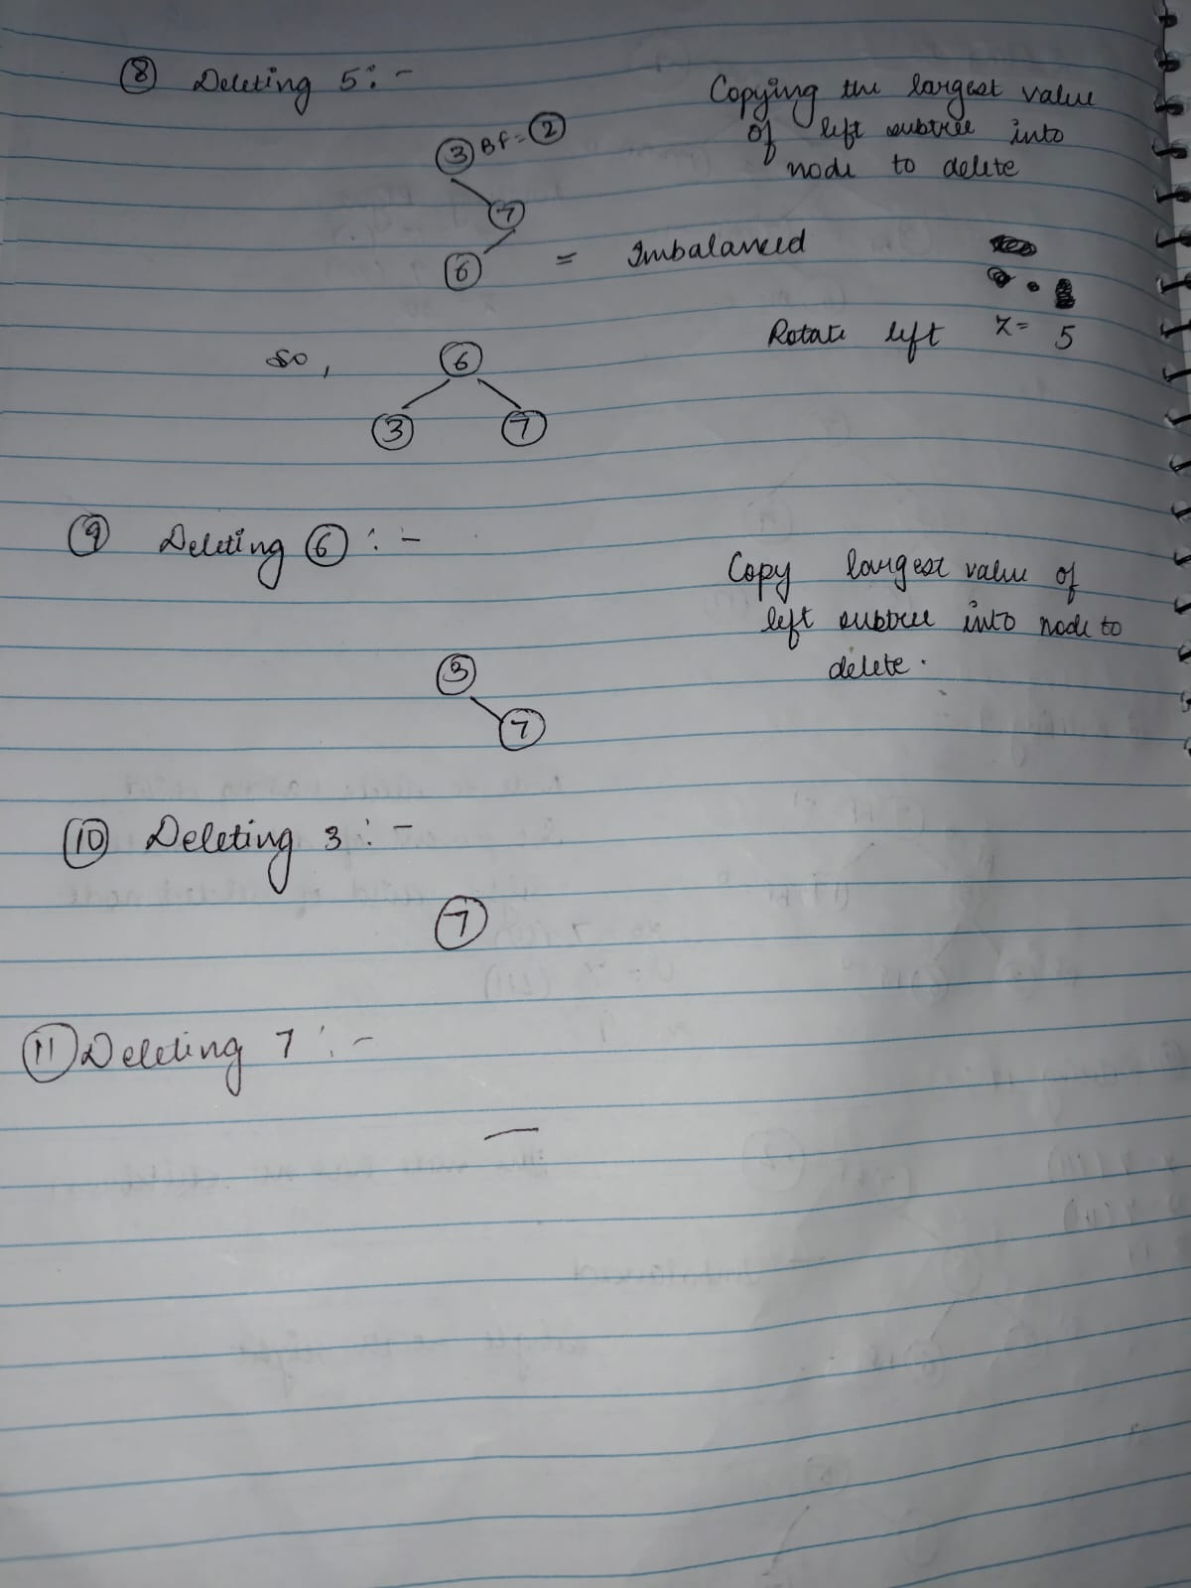PSEUDOCODE:
function rebalanceBST(root):
values = [] // Step 1: Create empty list
collectInOrder(root, values) // Step 2: Fill list with sorted values
return buildTree(values, 0, length(values) - 1) // Step 3: Build balanced BST

function collectInOrder(node, list):
if node is null:
return
collectInOrder(node.left, list)
list.add(node.value)
collectInOrder(node.right, list)

function buildTree(arr, left, right):
if left > right:
return null
mid = (left + right) // 2
root = new Node(arr[mid])
root.left = buildTree(arr, left, mid - 1)
root.right = buildTree(arr, mid + 1, right)
return root
Description
This algorithm takes any binary search tree (BST), even if it is highly unbalanced, and builds a new BST that is balanced and has height around O(logn). The process works in two main phases.
First, the algorithm goes through the tree using in-order traversal and records each node’s value into a list. This ensures the values are stored in sorted order because in-order traversal of a BST always visits nodes from smallest to largest.
Next, the algorithm builds a new tree from that sorted list by repeatedly picking the middle value to be the root. The left half of the list becomes the left subtree, and the right half becomes the right subtree. This recursive splitting keeps the tree as balanced as possible at every level.
Since each node is visited only once during traversal and once during reconstruction, the total time taken is linear in the number of nodes. The resulting tree keeps the binary search property and is balanced in structure, making operations like search, insert, and delete efficient.
Why the Algorithm Takes Linear Time ???
The total time complexity is O(n) because:
In-order Traversal
- Each node in the tree is visited once during the in-order traversal.
- For every node, we perform a constant amount of work (appending to a list).
- So, for n nodes, the traversal takes:
O(n)
Building the Balanced BST
- The recursive function buildBalancedBST also creates one node per list element.
- At each step:
  - We select the middle index (O(1)),
  - We create a node (O(1)),
  - Then we recurse on left and right halves.
- Since no element is visited more than once, and each node is constructed with constant work, this step also takes:
O(n)
Total Time
Adding the two steps:
- In-order traversal: O(n)
- Tree construction: O(n)
⇒Total Time=O(n)+O(n)=O(n)
No sorting is needed
No rotations or AVL balancing logic
Each element is processed a fixed number of times

